
REPUBLIC OF CAMEROON
Peace-Work-Fatherland
MINISTER OF HIGHER EDUCATION

FACULTY OF ENGINEERING AND TECHNOLOGY
REPUBLIQUE DU CAMEROON
PAIX-Travail-Patrie
MINISTRE DE L’ENSEIGNEMENT SUPERIEUR

FACULTE DE L’INGINEURIE ET DE TECHNOLOGIES

********************** UNIVERSITY OF BUEA *************************

DEPARTMENT OF COMPUTER ENGINEERING
COURSE: CEF440 (INTERNET PROGRAMMING AND MOBILE PROGRAMMING)
TASK 1

NAMES | REGISTRATION NUMBER
AJAMAH GODLOVE NKEMAJAH | FE21A129
AMABO JOSHUA NGWA | FE21A135
FUKA NEVILLE TENYI | FE21A199
MBACHAM LOANA NING | FE21A228
NGOUNG TASSA ALAIN SHIRESS | FE21A262
NYUYSEVER BORIS DINYUY | FE21A295

SUPERVISED BY: Dr. Nkemeni Valery
MARCH 2024

Table of Contents
- REVIEW AND COMPARISON OF MAJOR TYPES OF MOBILE APPLICATIONS 2
- REVIEW AND COMPARISON BETWEEN MOBILE APP PROGRAMMING LANGUAGES 5
- REVIEW AND COMPARISONS BETWEEN MOBILE APP DEVELOPMENT FRAMEWORKS 11
- STUDY OF MOBILE APPLICATION ARCHITECTURES AND DESIGN PATTERNS 16
- COLLECTION AND ANALYSIS OF USER REQUIREMENTS FOR A MOBILE APPLICATION (REQUIREMENT ENGINEERING) 20
- ESTIMATION OF MOBILE APP DEVELOPMENT COST AND REFERENCES 22

Task 1
- REVIEW AND COMPARISON OF MAJOR TYPES OF MOBILE APPLICATIONS
- Introduction:
A mobile application, commonly referred to as a mobile app, is a software program specifically designed to run on mobile devices such as smartphones, tablets, smartwatches, or other handheld devices. Mobile applications are developed to provide various functionalities, services, and experiences to users, typically through the use of a mobile operating system (e.g., iOS, Android, or Windows Mobile). Mobile applications can serve a wide range of purposes, such as: Utility app, social media apps, entertainment apps, productivity apps,E-commerce apps etc..
THE MAJOR MOBILE APPLICATION TYPES
- Native Applications (Native apps):
- Native apps are developed specifically for a particular mobile platform or operating system, such as iOS or Android, using platform-specific programming languages (Objective-C or Swift for iOS, Java or Kotlin for Android).
- They have direct access to the device's hardware and features, resulting in high performance and seamless user experience.
- Native apps are typically distributed through app stores and installed directly on the user's device.
- They can take full advantage of platform-specific features, such as push notifications, camera access, GPS, and offline capabilities.
- Development for each platform requires separate codebases, which can increase development time and cost.

- Progressive Web Applications (PWAs) or Web Apps:
- PWAs are web applications that can be accessed through a web browser but offer a user experience similar to native apps.
- They are built using web technologies like HTML, CSS, and JavaScript.
- PWAs can be "installed" on a user's home screen, providing an app-like experience.
- They can work offline or in low-connectivity situations using caching and storage capabilities.
- PWAs are cross-platform and can run on multiple devices and operating systems.
- They don't have full access to all device features and APIs like native apps do.

- Hybrid Application:
- Hybrid apps are a combination of web technologies (HTML, CSS, JavaScript) and native wrappers.
- They are built using frameworks like React Native, Ionic, or Xamarin, which allow developers to write code once and deploy it across multiple platforms.
- Hybrid apps can access some native device features through plugins or APIs.
- They are distributed through app stores and installed on the user's device.
- Hybrid apps can have reduced performance compared to fully native apps, especially for complex or resource-intensive tasks.
- Development time and cost can be lower compared to maintaining separate native codebases, but there may be limitations in accessing certain platform-specific features.

- Comparison Between the types of Applications

Please see the next page

Properties | Native Apps | Web Apps | Hybrid Apps
Development | Platform-specific development using native programming languages and tools | Web technologies (HTML, CSS, JavaScript) | Combination of native and web development
Performance | High performance due to direct access to device features and optimized code | Dependent on browser performance and internet connection | Performance can vary based on the implementation
User Experience | Native look and feel, leveraging platform-specific UI elements | Consistent experience across platforms, but may lack native features | Can mimic native look and feel, but may not be as seamless
Access to Features | Full access to device hardware and software features | Limited access to device features, relies on browser capabilities | Access to device features via plugins or web APIs
Distribution | App stores (e.g., Apple App Store, Google Play Store) | Accessed via web browsers | App stores or web distribution depending on the approach
Development Cost | Higher development cost and effort due to platform-specific development | Lower development cost and effort due to code reuse across platforms | Moderate development cost due to combination of approaches
Offline Support | Full offline support with data and functionality stored locally | Limited offline support, as web apps require internet connectivity | Varies depending on the implementation and caching strategy
Updates | Updates require approval and distribution through app stores | Instant updates, accessible to users without app store approval | Updates can be distributed via app stores or web deployment
Cross-Platform | Not cross-platform; separate development for each platform | Cross-platform, accessible from any device with a web browser | Cross-platform, leveraging code reuse for multiple platforms
Examples | Instagram, WhatsApp (native versions) | Twitter, LinkedIn | Facebook, Instagram (hybrid versions)

- REVIEW AND COMPARISON BETWEEN MOBILE APP PROGRAMMING LANGUAGES

- Introduction:
A mobile app programming language refers to the specific programming language used to develop applications for mobile devices such as smartphones and tablets. There are several popular programming languages used for mobile app development, such as Java, kotlin, swift, Objective-C, C#, Javascript, Dart etc...
- Some Popular Programming Language App.
- Java:
- Java is a widely used programming language for Android app development.
- It has a large community and extensive libraries and frameworks available.
- Java offers strong security features and good performance.
- Android Studio, the official integrated development environment (IDE) for Android, supports Java development.
- Kotlin:
- Kotlin is a modern programming language developed by JetBrains, and it is the preferred language for Android app development.
- It is fully interoperable with Java, allowing developers to leverage existing Java codebases.
- Kotlin offers concise syntax, null safety, and enhanced developer productivity.
- It is officially supported by Google for Android development and is gaining popularity among Android developers.
- Swift
- Swift is Apple's programming language for iOS, macOS, watchOS, and tvOS app development.
- It offers a modern and expressive syntax, making code more readable and maintainable.
- Swift provides safety features like type inference, optionals, and memory management.
- It is designed to work seamlessly with the Cocoa and Cocoa Touch frameworks.
- Xcode, the official IDE for iOS development, supports Swift programming.
- Objective-C
- Objective-C is the legacy programming language for iOS and macOS app development.
- It has been around for a long time and has an extensive library ecosystem.
- Many existing iOS apps and frameworks are written in Objective-C.
- Objective-C is still used, but its usage has declined in favor of Swift.
- Javascript
- JavaScript is a popular programming language for building cross-platform mobile apps using frameworks like React Native and Ionic.
- It allows developers to write code once and deploy it on multiple platforms.
- JavaScript has a vast ecosystem of libraries and frameworks that enable rapid development.
- It is primarily used for hybrid and progressive web app (PWA) development.

- Differences between the various programming languages

Properties | Java | Kotlin | Swift | Objective-C | JavaScript
Platform | Cross-platform (Android, desktop, web) | Cross-platform (Android, desktop, web) | iOS, macOS, watchOS, tvOS | iOS, macOS | Web
Syntax | C-like syntax | Concise syntax, improved readability | Modern syntax, easy to read and write | C-like syntax | ECMAScript-based scripting language
Null Safety | No native null safety support | Native null safety support | No native null safety support | No native null safety support | No native null safety support
Interoperability | Java interoperability | Full interoperability with Java | Limited interoperability with Objective-C | Full interoperability with Objective-C | JavaScript interoperability
Developer Adoption | Widely adopted in enterprise and Android development | Rapidly growing adoption in Android development | Primary language for iOS and macOS development | Legacy language for iOS and macOS development | Widely adopted for web development
Ecosystem | Large ecosystem of libraries and frameworks | Growing ecosystem with Kotlin-specific libraries | Rich ecosystem with Apple frameworks and libraries | Mature ecosystem with Apple frameworks and libraries | Vast ecosystem with numerous frameworks and libraries
Tooling | Mature tooling and development environments | Strong integration with Android Studio | Comprehensive tooling and Xcode IDE | Xcode IDE and third-party tools | Abundance of development tools and framework
Learning Curve | Moderate learning curve for beginners | Smooth transition from Java | Moderate learning curve for experienced developers | Moderate learning curve for Java developers | Relatively easy to learn for web developers
Community Support | Active and vibrant community support | Growing community support | Active and supportive community | Active community support | Active community support

- Review and Comparisons between mobile app development frameworks
- Introduction:
A software framework is a reusable set of libraries, tools, and components that provides a structured foundation for developing applications. It offers pre-defined structures, guidelines, and functionality to simplify the development process and promote code reusability. Frameworks often enforce certain architectural patterns or programming paradigms. Some key characteristics and benefits of software frameworks include: abstraction, reusability, structure and guidelines, standardizations, extensibility, community and Support, rapid development, security, scalability and cross-platform development.

- Some popular Mobile App development frameworks

- React Native:
- Language: JavaScript
- Performance: Good performance with native-like UI components.
- Cost & Time to Market: Offers code reusability, reducing development time and cost.
- UX & UI: Provides a rich set of pre-built UI components and allows for easy customization.
- Complexity: Relatively easy to learn for web developers familiar with JavaScript.
- Community Support: Large and active community with extensive libraries and resources.
- Usage: Cross-platform development for iOS and Android.
- Flutter:
- Language: Dart
- Performance: Excellent performance with a native-like user interface.
- Cost & Time to Market: Offers code reusability, reducing development time and cost.
- UX & UI: Provides a customizable UI toolkit with a wide range of widgets.
- Complexity: Requires learning Dart, but the framework itself is designed to be easy to use.
- Community Support: Growing community with increasing popularity and support.
- Usage: Cross-platform development for iOS, Android, web, and desktop.

- Xamarin:
- Language: C#
- Performance: Native-like performance as apps are compiled to native code.
- Cost & Time to Market: Code sharing between platforms reduces development time and cost.
- UX & UI: Supports native user interfaces and platform-specific UI components.
- Complexity: Requires proficiency in C# and understanding of platform-specific APIs.
- Community Support: Solid community support with Microsoft backing.
- Usage: Cross-platform development for iOS, Android, and Windows.

- Nativescript:
- Language: JavaScript or TypeScript
- Performance: Native performance with direct access to native APIs.
- Cost & Time to Market: Code sharing between platforms reduces development time and cost.
- UX & UI: Supports native UI components and offers flexibility for custom UI.
- Complexity: Requires knowledge of JavaScript/TypeScript and platform-specific APIs.
- Community Support: Active community with various plugins and resources.
- Usage: Cross-platform development for iOS and Android.

- Ionic:
- Language: HTML, CSS, JavaScript/TypeScript
- Performance: Good performance, but not as fast as truly native apps.
- Cost & Time to Market: Code reusability and rapid development reduce time and cost.
- UX & UI: Provides a library of pre-built UI components that are customizable.
- Complexity: Relatively easy to learn for web developers familiar with HTML, CSS, and JavaScript/TypeScript.
- Community Support: Active community with extensive documentation and plugins.
- Usage: Cross-platform development for iOS, Android, and web.

- Comparison between different frameworks

Properties | React Native | Flutter | Xamarin | NativeScript | Ionic
Platform | Cross-platform (iOS, Android) | Cross-platform (iOS, Android, Web, Desktop) | Cross-platform (iOS, Android, macOS, Windows) | Cross-platform (iOS, Android) | Cross-platform (iOS, Android, Web)
Language | JavaScript | Dart | C# | JavaScript/TypeScript | JavaScript/TypeScript
UI Rendering | Native components rendered using JavaScript and bridge | Custom UI rendered using Skia graphics engine | Native components rendered using .NET runtime | Native components rendered using JavaScript and bridge | Native components rendered using web technologies (HTML, CSS)
Performance | Good performance, but can have limitations in complex UI | Excellent performance due to compiled code and Skia engine | Good performance with access to platform-specific optimizations | Good performance, but can have limitations in complex UI | Moderate performance due to web-based rendering
Development | JavaScript and React development skills required | Dart development skills required | C# and .NET development skills required | JavaScript and web development skills required | JavaScript and web development skills required
Native Access | Limited access to native features and APIs | Direct access to native features and APIs | Full access to native features and APIs | Direct access to native features and APIs | Limited access to native features and APIs
Ecosystem | Large and active community with a wide range of libraries | Growing ecosystem with Flutter-specific libraries and packages | Mature ecosystem with extensive .NET libraries and components | Active community with NativeScript-specific libraries and plugins | Active community with Ionic-specific libraries and plugins
Hot Reload | Fast hot reload for quick code changes and UI updates | Hot reload with sub-second reload times | Fast hot reload for quick code changes and UI updates | Fast hot reload for quick code changes and UI updates | Fast hot reload for quick code changes and UI updates
Learning Curve | Relatively easy learning curve for web developers | Moderate learning curve due to Dart and custom UI framework | Moderate learning curve due to .NET and platform-specific APIs | Moderate learning curve for web developers | Relatively easy learning curve for web developers

- Study Of Mobile Application Architectures and Design Patterns
- Introduction:
Mobile application architectures and design patterns are frameworks and guidelines that help structure and organize the codebase of mobile applications. They provide a systematic approach to building scalable, maintainable, and extensible mobile apps. Here are some commonly used mobile application architectures and design patterns: Model-View-Control (MVC),Mobile-View Presenter (MVP), Mobile-View-ViewModel (MVVM),Clean Architecture, Flux/redux, Dependency Injection (DI), Singleton, Observer etc…

- Various Architecture and Design Patterns
- Model-View-Controller (MVC):
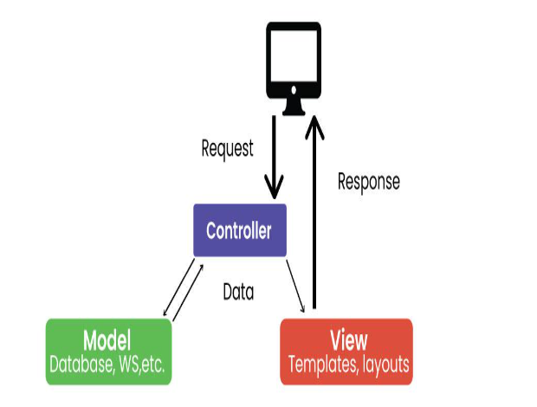

FEATURES
- MVC is a widely used design pattern that separates an application into three main components: Model, View, and Controller.
- The Model handles data and business logic.
- The View represents the user interface.
- The Controller handles user input and acts as a mediator between the Model and View.
- MVC helps to separate concerns and promotes code reusability.

- Model-View-Presenter (MVP):

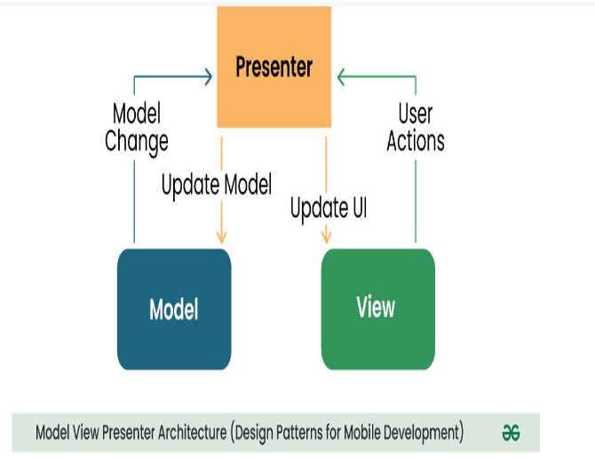
FEATURES
- MVP is an architectural pattern that separates an application into three components: Model, View, and Presenter.
- The Model handles data and business logic.
- The View represents the user interface.
- The Presenter acts as an intermediary between the Model and View, handling user input and updating the UI.
- MVP aims to improve testability by decoupling the View from the business logic.

- Model-View-ViewModel (MVVM):

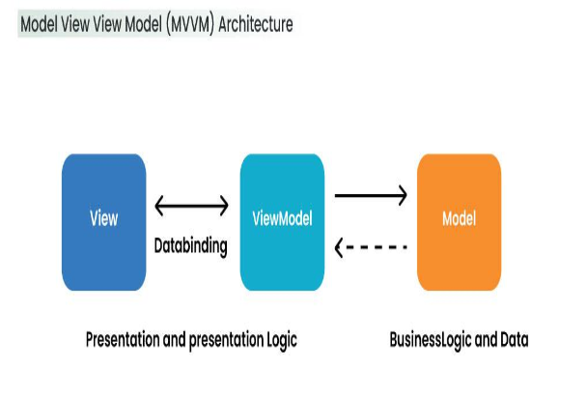

FEATURES
- MVVM is an architectural pattern that separates an application into three components: Model, View, and ViewModel.
- The Model handles data and business logic.
- The View represents the user interface.
- The ViewModel exposes data and commands to the View, abstracting the business logic.
- MVVM promotes a clear separation between the View and business logic, enabling easier testing and maintainability.

- Clean Architecture:

FEATURES
- Clean Architecture is a software architecture principle that emphasizes separation of concerns and decoupling of dependencies.
- It consists of multiple layers: Presentation, Domain, and Data.
- The Presentation layer handles UI-related logic.
- The Domain layer contains business logic and use cases.
- The Data layer deals with data access and external interfaces.
- Clean Architecture promotes testability, maintainability, and flexibility.

- Reactive Programming:
FEATURES
- Reactive Programming is a programming paradigm that focuses on asynchronous data streams and event-driven programming.
- It allows developers to handle data and events in a declarative and composable manner.
- Reactive programming libraries/frameworks like RxJava, RxSwift, or ReactorKit provide abstractions for handling streams of data and events.
- Reactive programming can enhance responsiveness and maintainability in mobile apps.

- Flux/Redux:
FEATURES

- Flux and Redux are architectural patterns that implement a unidirectional data flow.
- They emphasize immutability and a single source of truth for application state.
- Actions trigger state updates, which are handled by reducers to produce a new state.
- The updated state is then propagated to the UI for rendering.
- Flux/Redux can simplify state management and enable better debugging and predictability.

- Collection and Analysis of User Requirements for a Mobile Application (Requirement Engineering)

- Introduction:
The collection and analysis of user requirements for a mobile application, also known as requirement engineering, is the process of identifying, gathering, and understanding the needs, preferences, and expectations of users in order to define the functional and non-functional specifications of the application. It involves systematically eliciting, documenting, and analyzing these requirements to ensure that the final mobile application meets the desired objectives and provides a satisfactory user experience.
The collected requirements are then analyzed, prioritized, and documented to serve as a foundation for the development of the mobile application. This process ensures that the final product aligns with user expectations, business objectives, and technological feasibility.

- Stages of Collection Requirement Engineering

- Identify Stakeholders: The first step in requirement engineering is identifying the stakeholders who have an interest or influence in the mobile application. Stakeholders can include end users, clients, business owners, product managers, developers, and other relevant parties. Understanding the perspectives and expectations of different stakeholders is crucial for capturing comprehensive requirements.
- Gather User Requirements: User requirements are gathered through various techniques such as interviews, surveys, focus groups, and observations. The goal is to elicit information about the users' needs, preferences, and desired functionality of the mobile application. It's important to involve representative users who can provide insights into the target audience's preferences and usage patterns.
- Prioritize Requirements: Once the requirements are gathered, they need to be prioritized based on their importance and feasibility. This involves analyzing and categorizing the requirements into must-have, should-have, and nice-to-have. Prioritization helps in managing scope, setting project goals, and making informed decisions during development.
- Define Functional and Non-functional Requirements: Functional requirements specify what the mobile application should do in terms of features, interactions, and user interfaces. Non-functional requirements focus on the qualities and constraints of the application, such as performance, security, usability, and compatibility. Both types of requirements need to be clearly defined and documented to ensure a comprehensive understanding of the application's capabilities.
- Validate and Verify Requirements: The collected requirements should be validated and verified with stakeholders to ensure accuracy, completeness, and clarity. This involves conducting reviews, walkthroughs, and prototyping sessions to gather feedback and make necessary revisions. Regular communication and collaboration with stakeholders throughout the requirement engineering process are essential to align expectations and address any ambiguities or conflicts.
- Document Requirements: Documentation plays a crucial role in requirement engineering. The requirements should be documented in a clear, organized, and unambiguous manner. This includes creating requirement specifications, use cases, user stories, and other relevant artifacts that serve as a reference for the development team.
- Manage Requirements Changes: Requirements are subject to change throughout the development lifecycle due to evolving user needs, market conditions, and technological advancements. It's important to establish a change management process that allows for capturing, evaluating, and implementing requirement changes while considering their impact on the project timeline, budget, and overall feasibility.

NOTE: Effective requirement engineering ensures that the mobile application aligns with user expectations and business goals. It establishes a solid foundation for the development team to design, build, and deliver a high-quality application that meets user needs and provides a positive user experience.

- Estimation of Mobile App Development Cost
- Introduction:
Estimation of mobile app development cost refers to the process of determining the financial investment required to develop a mobile application. It involves analyzing various factors, such as project scope, complexity, features, platform compatibility, design requirements, development resources, and other cost-related considerations. The estimation helps in providing a ballpark figure or a detailed breakdown of the expected expenses associated with developing the mobile app. It assists stakeholders, including clients, project managers, and development teams, in planning budgets, making informed decisions, and ensuring financial feasibility throughout the app development lifecycle. It's important to note that mobile app development cost estimation is an iterative process and can be subject to revisions as more details about the project become available.

- Steps in Estimating Mobile App Development Cost
1. Define Project Scope:
- Clearly define the scope of the mobile app project, including its features, functionalities, platforms (iOS, Android, or both), and any integrations with external systems.

2. Identify Resource Requirements:
- Determine the skill sets and resources needed for the project, including developers, designers, project managers, and quality assurance professionals.
- Consider the level of expertise required, such as junior, mid-level, or senior developers.

3. Break Down Tasks and Effort Estimation:
- Divide the project into specific tasks and functionalities.
- Estimate the effort required for each task, considering factors like complexity, development time, and potential dependencies.

4. Consider Design and User Experience (UX):
- Design and UX play a significant role in the development cost.
- Assess if you require custom designs, animations, or complex user interactions, as these can increase development time and cost.

5. Account for Backend Development:
- Determine if the app requires backend development, such as server infrastructure, APIs, databases, and cloud services.
- Backend development complexity can impact the overall cost.

6. Evaluate Third-Party Integrations:
- Assess if the app needs integration with external services or APIs, such as payment gateways, social media platforms, or mapping services.
- Consider the effort and cost associated with implementing and testing these integrations.

7. Consider Testing and Quality Assurance:
- Allocate resources and time for thorough testing and quality assurance to ensure a robust and stable application.
- Testing efforts should cover functional testing, compatibility testing, performance testing, and security testing.

8. Include Project Management and Communication:
- Account for project management, coordination, and communication efforts.
- Project management activities, such as planning, coordination, and reporting, contribute to the overall cost.

9. Factor in Additional Costs:
- Consider additional costs, such as licensing fees for third-party libraries or frameworks, cloud hosting fees, and ongoing maintenance and support expenses.

10. Research Market Rates:
- Research the prevailing market rates for mobile app development services in the specific geographic region or industry.
- Consider the rates based on the skill level and experience of the development team.

11. Adjust for Contingencies:
- Add a contingency buffer to account for uncertainties, changes in requirements, and potential delays.

NOTE: It's essential to note that these steps provide a general framework for estimating mobile app development costs. The complexity of the project, the geographical location of the development team, and other factors can influence the final cost. Consulting with experienced app development agencies or professionals can provide more accurate and detailed cost estimates based on your specific project requirements.

ReferENCES

- WIKIPEDIA
- Mobile Application Development MSCIT-302
- A Comprehensive Guide to Mobile App Architecture MaddappGang.com

